2.7: a) The van will travel 480 m for the first 60 s and 1200 m for the next 60 s, for a total distance of 1680 m in 120 s and an average speed of 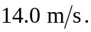 b) The first stage of the journey takes 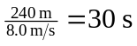 and the second stage of the journey takes 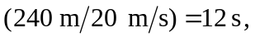 so the time for the 480-m trip is 42 s, for an average speed of 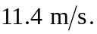 c) The first case (part (a)); the average speed will be the numerical average only if the time intervals are the same.

